Crystal Reporting X3 RPT File to X3 Notes

Reporting Work Stream

**Development > Script dictionary > Reports**

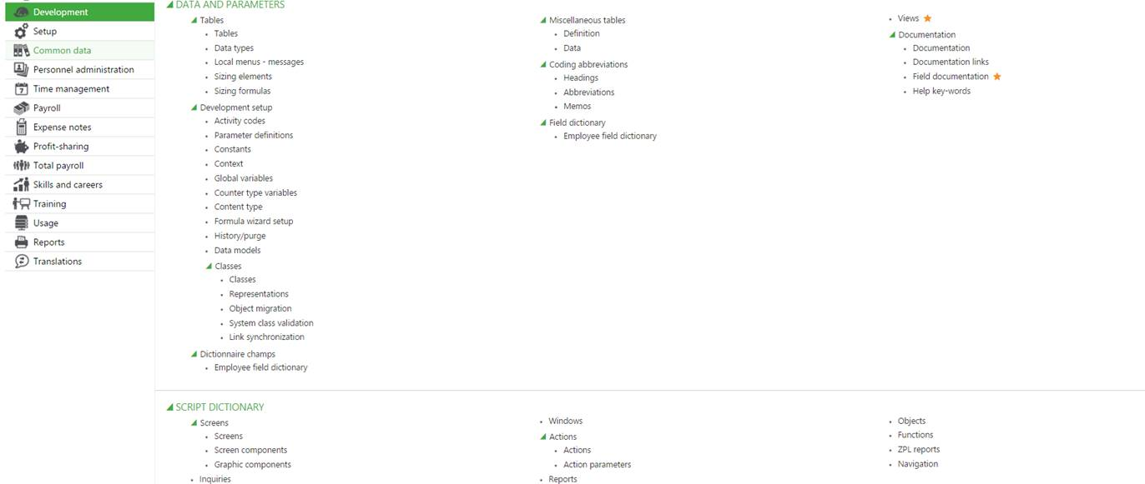

Create New Report Code

At Section for Crystal Report, Provide the report name that is the actual RTP File Name

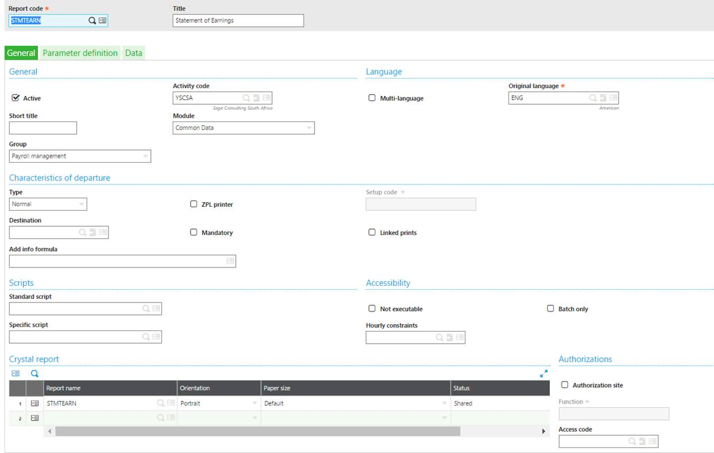

Complete the parameters exactly the same as on the Crystal Report

